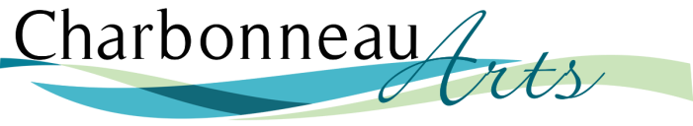

Dear Friend,

It is with great excitement that we invite you to participate in a very special event -- The 2019 Charbonneau Arts Festival “Art with Flair,” benefiting the art programs of our high schools in Wilsonville and Canby. This year’s festival fundraiser will be the weekend of Friday through Sunday, November 1, 2 & 3, 2019 at the Charbonneau Country Club. We are seeking donations for the opening night Silent Auction and for our festival raffles, which continue through the remainder of the weekend. Your support will make a big difference!

As you know, there is little (if any) funding for the art programs in our schools. Our annual donation to them is graciously welcomed each year. In 2018 we were able to give $4,000 to each school, made possible in by the support of our sponsors and donors like you!

The GALA! Champagne Reception is the opening event for this weekend festival, beginning at 6pm until 9pm. The evening highlights our Silent Auction, our Fine Arts Gallery show, presents our Featured Artist, this year, Elaine Lueneke, an amazing Student Art Gallery, and offers an opportunity for all participants to vote their “People’s Choice.” A GALA! ticket can be purchased online or at the door.

Alongside the Gallery Show, on Saturday and Sunday we will launch this year’s Artisan Show, introducing dozens of talented artisans from all over our local area and beyond. Included will be excellent food and beverages, raffle, live entertainment, and student art demos. The weekend festival is free to the public.

We invite you to partner with us for Festival 2019 by donating an item to our auction or artisan show raffle. We are confident that your in-kind contribution will allow us to increase the funds raised for the children who need it most – we hope you will join us! You will receive a receipt for your gift and full publicity with the donated item.

This letter introduces you to our volunteer who is helping our organization present our event to you and your business. If you have any questions about the Charbonneau Arts Association and our festival, please feel free to check us out at https://charbonneauarts.org or email either of our volunteer chairs for the 2019 Charbonneau Arts Festival Silent Auction: Joan Vedder or Elaine Swyt at info@charbonneauarts.org.

Thank you in advance for your support!
Sincerely,
Charbonneau Arts Festival 2019
Committee Volunteer
The Charbonneau Art Association is a non-profit 501(c)(3) organization that supports public art education programs in local high schools. Your contribution is tax deductible to the extent allowed by law and makes you eligible to participate in the tax credit program of the Oregon Cultural Trust, www.culturaltust.org. Donor information is not shared with or sold to any outside organization. Federal ID# 47-4653404

